Q1.
Answer is B.

A: Gets customers who have orders where order_status = 'Shipped'.Wrong
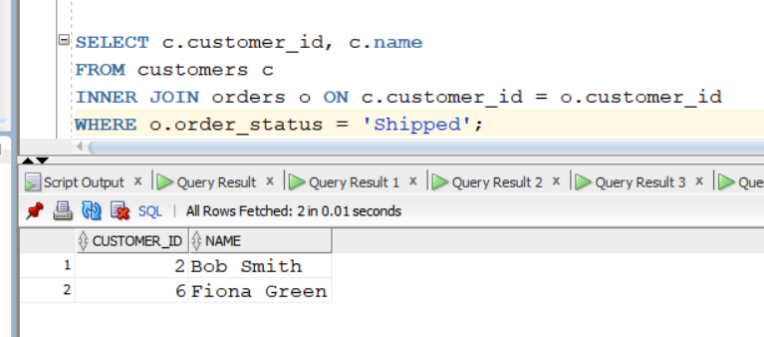

B: Correct because it matches the condition:placed orders but not yet received shipments.
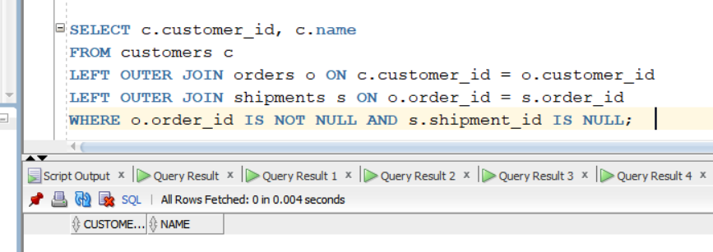

C: Finds customers with orders where status ≠ 'Shipped'.
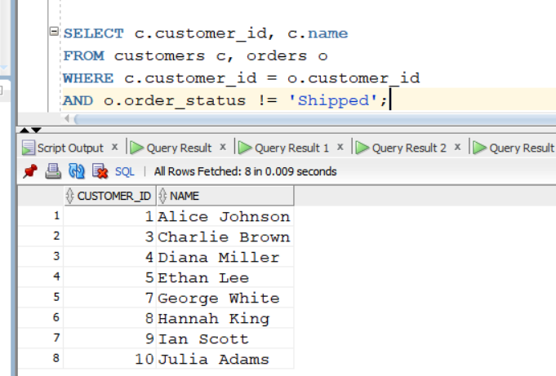

D: Gets customers with no orders (order_status IS NULL).
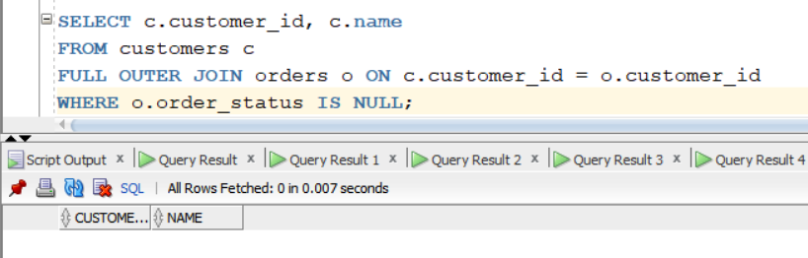

Q2.
Answer is B.

A: Aliases do not make queries faster; they just make them easier to read.

B: To distinguish between multiple instances of the same table
Using aliases (e1, e2) fixes that ambiguity.
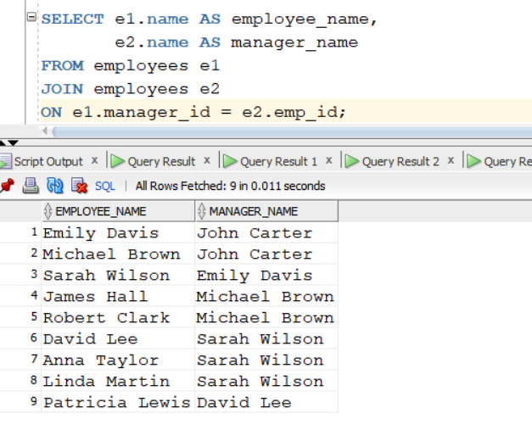

C: Aliases are not real temporary tables — just short names within a query.

D: Referential integrity is done with foreign keys, not aliases.

Q3.
Answer is C.

A: Wrong, because it excludes departments with no employees.
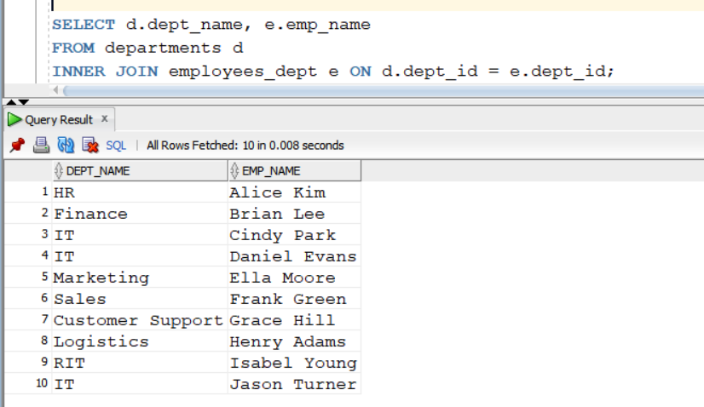

B: cross join create a Cartesian product.Example 10x10 = 100
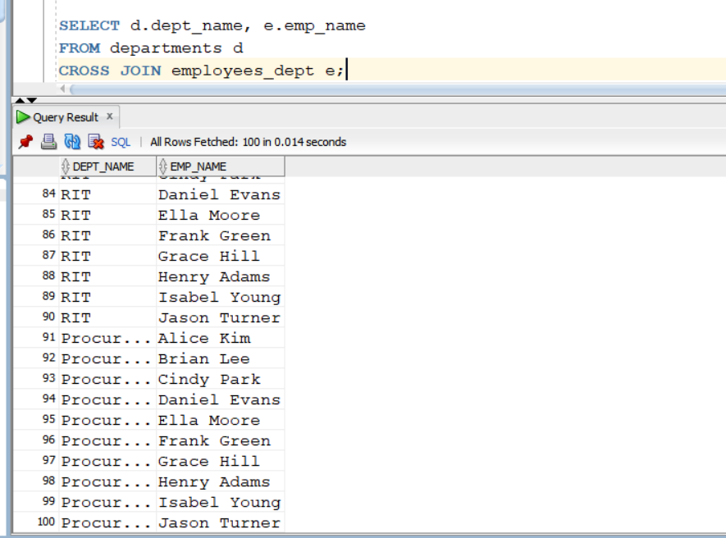

C: Returns all rows from the left table (departments). If a department has no employees, the employee columns will show NULL.
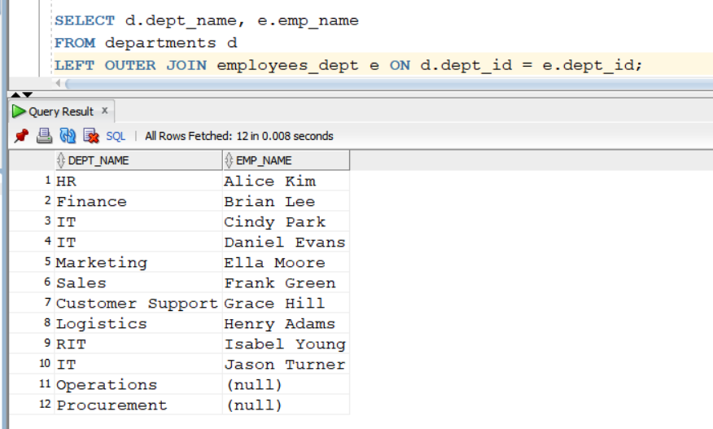

D: Wrong direction, it keeps all employees, not all departments.
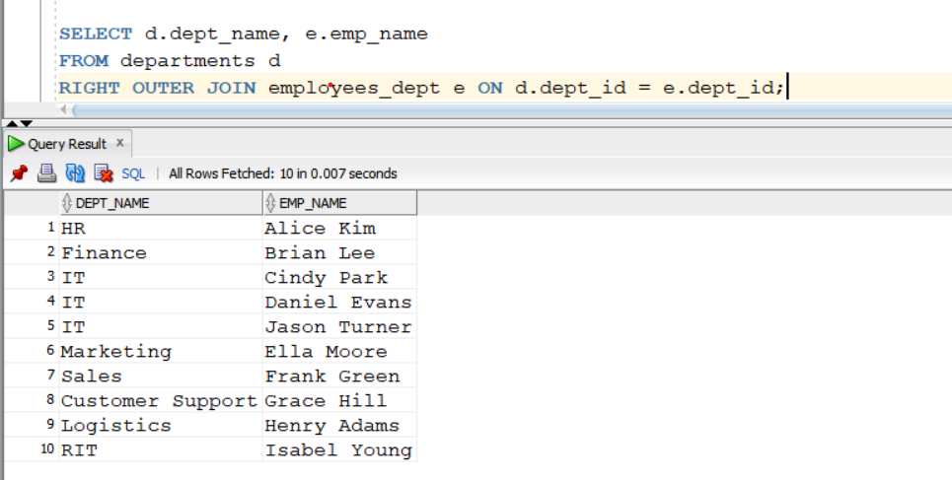

Q4.
Answer is B.

A: If Alice manages 2 employees, Alice will appear twice.duplicates are possible.
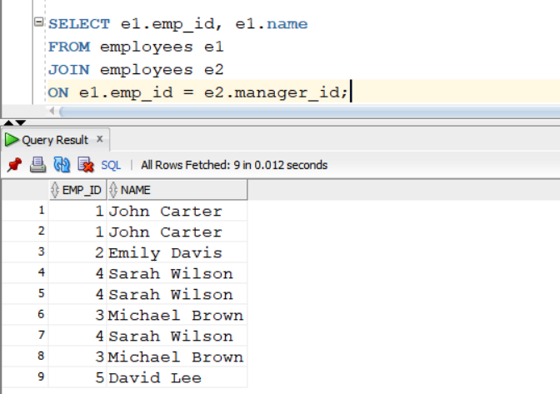

B: Work correctly.DISTINCT, which removes duplicates.
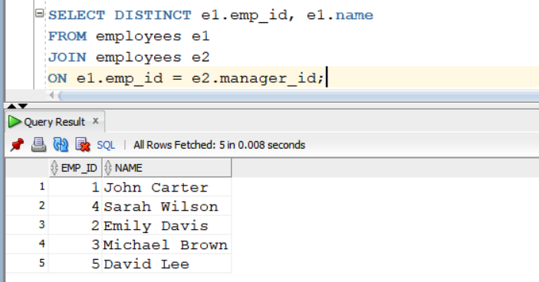

C:Also correct.But using subquery and B is more sample. 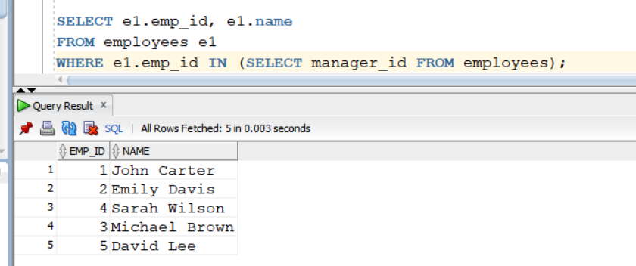

D: This is overly complex and give duplicate rows.
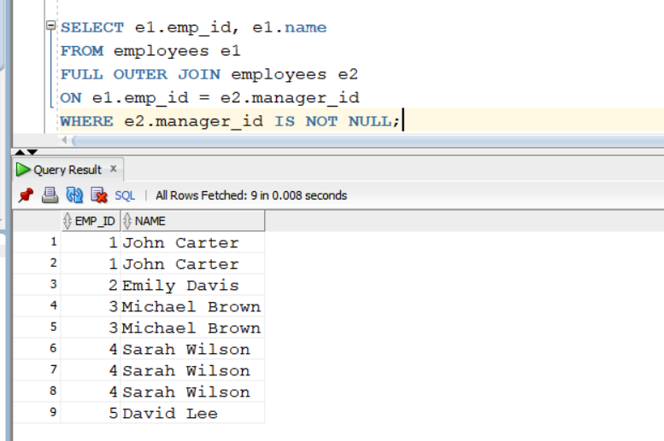

Q5.
Answer is C.

A: Returns only customers who have orders.
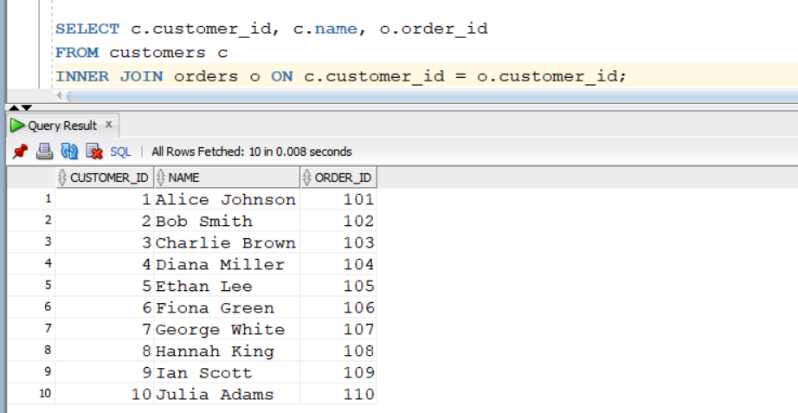

B: Left Join.
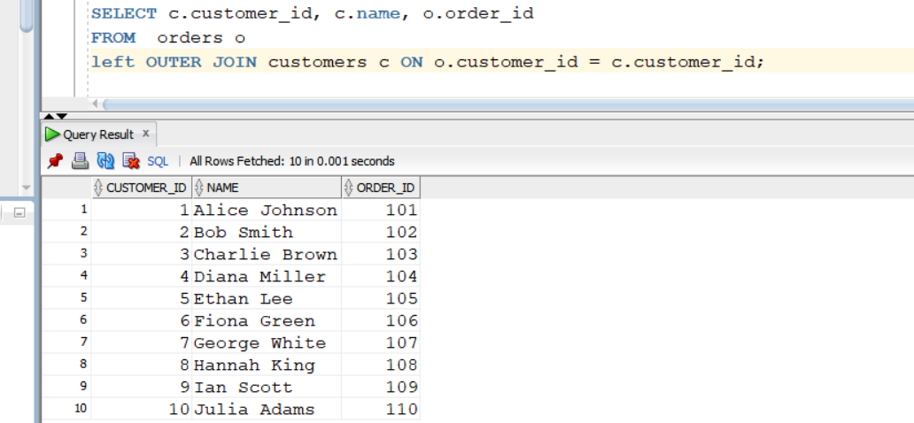

C: Right join
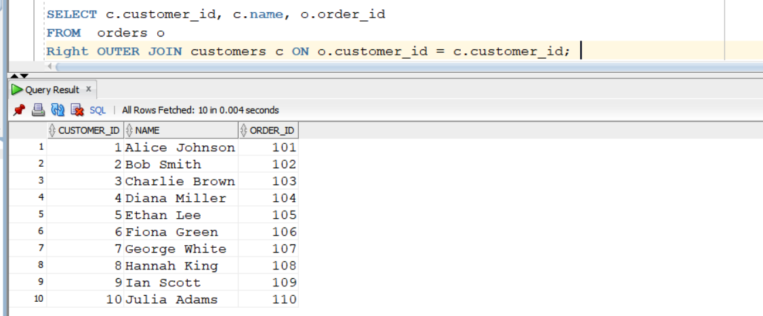

D: Returns all customers and all orders, whether matched or not.
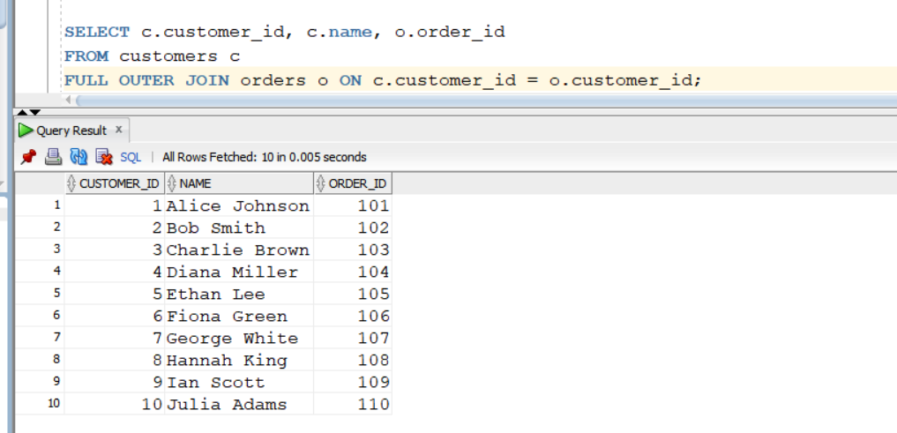

Q6.
Answer is B.

A: CROSS JOIN does not modify data. It cannot violate foreign keys or other constraints because it’s a read-only operation.

B: CROSS JOIN can produce extremely large result. TableA 10 rows, TableB 10 rows and cross join make 10x10 = 100.

C: CROSS JOIN do’nt produce duplicate row only. It can duplicates only appear if the source tables have duplicate rows.

D: Incorrect. Syntax is simple.

Q7.
Answer is B.

A: Returns all departments and all employees,unmatch with requirement.
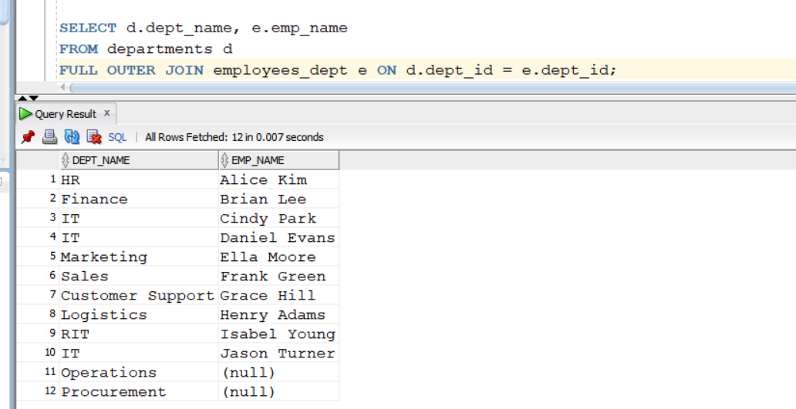

B: Returns all departments from the left table first.Second return employee name and null if no employee
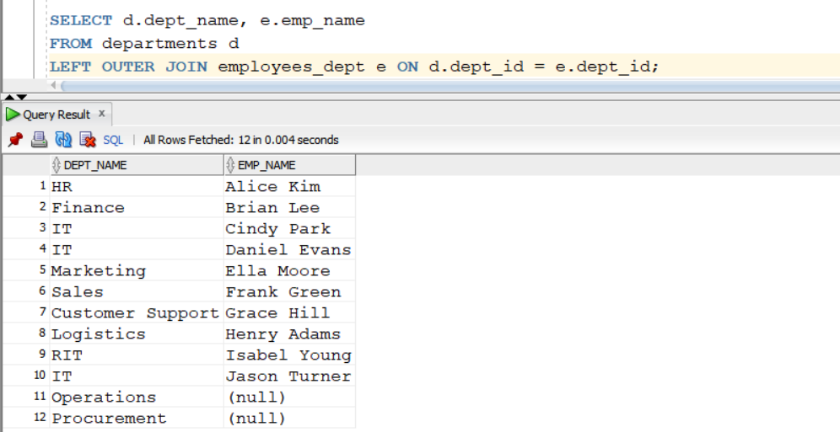
C: Returns all employees (right table) even if their department does not exist.
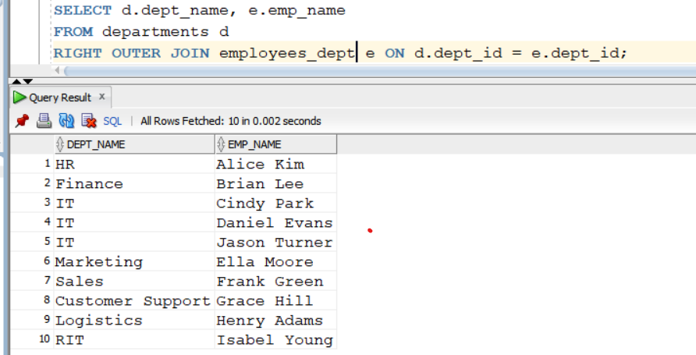

D: returns nothing, because no row from an INNER JOIN will have NULL emp_name.
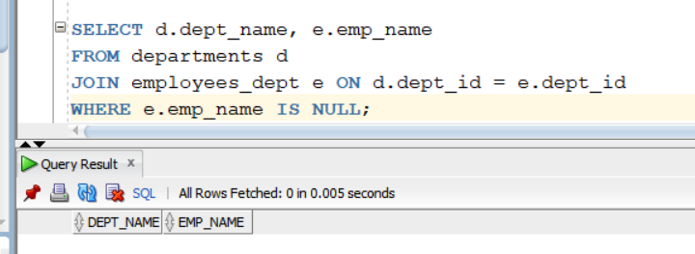

Q8.
Answer is C.

A: INNER JOIN only returns rows where all join conditions match.
It never introduces NULLs for missing matches — unmatched rows are simply excluded. So INNER JOINs cannot cause unexpected NULLs.

B: Missing WHERE clauses might include unwanted rows, but they don’t cause NULLs. NULLs come from unmatched joins, not filtering.
C: Correct. OUTER JOINs (LEFT, RIGHT, FULL) include unmatched rows, filling NULL in columns from the table that has no match.

D: Subqueries do not inherently introduce NULLs. NULLs only appear if the subquery returns NULL values explicitly, which is unrelated to the join issue.

